|  |  |
| --- | --- |
| EX NO: 06 | ADT STACK |
| DATE:31-08-19 |

**Aim:**

To write a java console application to design a java interface for ADT Stack. Implement this interface using array and to verify the implementation by pushing a string.

**Requirement:**

Design a java interface for ADT Stack.

Implement this interface using array.

Provide necessary exception handling in both the implementation.

Verify the implementation by pushing a string data.

**Algorithm:**

**Step 1**: Create a mystack package.

**Step 2**: Create a separate class for calculation, mystack and stackexception.

**Step 3**: Create an interface class stack and implement it to all other class.

**Step 4**: Create the exception for seperate stackexception in the interface stack.

**Step 5**: Create a public void push() and string pop() and throw stack exception.

**Step 6**: Display the results.

**CLASS DIAGRAM:**

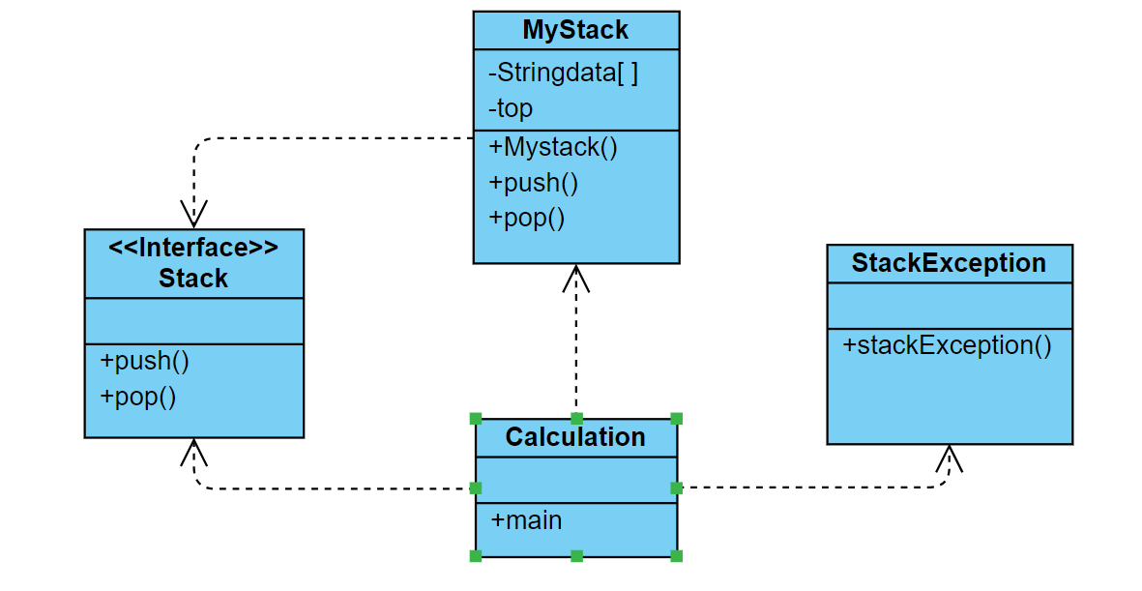

**PROGRAM:**

/*created by akhshy ganesh

* gmail id: akhshyganeshb@gmail.com

* program for Designing a Java interface for ADT Stack.

*/

**package** mystack;

**import** java.util.*;

**public** **class** Calculation {

**public** **static** **void** main(String[] args) {

String value1;

**int** option;

Stack st;

Scanner sc=**new** Scanner(System.***in***);

st=**new** MyStack(5);

**while**(**true**)

{

**try**

{

System.***out***.println("1. Push a String");

System.***out***.println("2. Pop a String");

System.***out***.println("3. Exit");

System.***out***.print("Enter your choice:");

option=sc.nextInt();

**switch**(option)

{

**case** 1:

System.***out***.print("Enter a String:");

value1=sc.next();

st.push(value1);

System.***out***.println("Push completed.");

**break**;

**case** 2:

value1=st.pop();

System.***out***.printf("Stack top value=%s\n",value1);

**break**;

**default**:

System.***out***.print("Please enter a valid number !!!");

}

**if**(option==3)

{

System.***out***.print("Thankyou for using stack application !!!");

**break**;

}

}**catch**(StackException e1)

{

System.***out***.println("Error:"+e1.getMessage());

}**catch**(NumberFormatException e2)

{

System.***out***.println("Error:"+e2.getMessage());

}

}

}

}

**OUTPUT:**

1. Push a String

2. Pop a String

3. Exit

Enter your choice:1

Enter a String:AK

Push completed.

1. Push a String

2. Pop a String

3. Exit

Enter your choice:1

Enter a String:AGS

Push completed.

1. Push a String

2. Pop a String

3. Exit

Enter your choice:2

Stack top value=AGS

1. Push a String

2. Pop a String

3. Exit

Enter your choice:3

Please enter a valid number !!!Thankyou for using stack application !!!

**RESULT:**

Thus the java console application for performing the string operation to push and pop using arraylist and thus the output is verified.